Manual Test Plan

OS Support:

Only Windows 10 running VS Code will be used for testing

First Run:

Go to the correct directory, then input

$python main.py -h

In the terminal that is integrated.

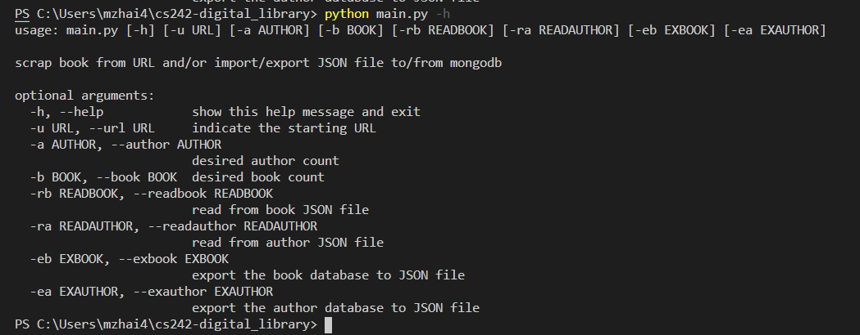

You will see the following help message clarifying all those parameters.

If you entered a wrong URL, that is, either a wrong formatted one, or any valid URL that is not pointing to Goodreads and representing a book, you will receive the error message:

Case 1: Not a valid URL



Case 2: Valid URL not pointing to Goodreads



Case 3: Valid Goodreads URL not representing a book



Case 4: Totally valid URL



Without other parameter, the scraper will start until 200 books or 50 authors has been collected.

If the author number is greater than 50



If the book number is greater than 200



If the URL is valid, book and author number set to 5



It will soon finish scraping.

Now we can try to use -eb function to export the database to a json file.

Note that it will not fail even if the file name is not correct.

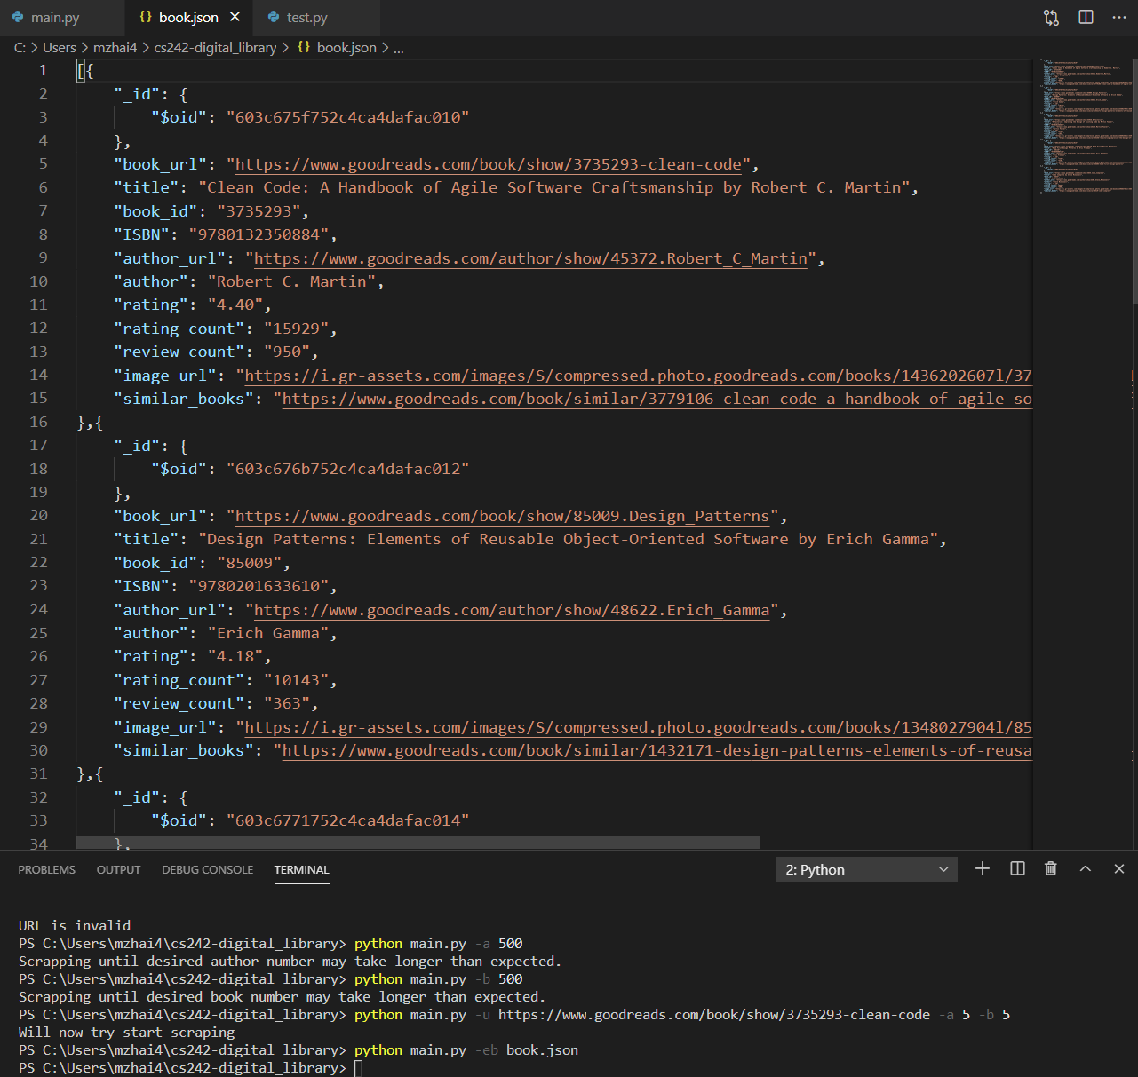

For example, the author file does not have “.json “, but still the file will be written.

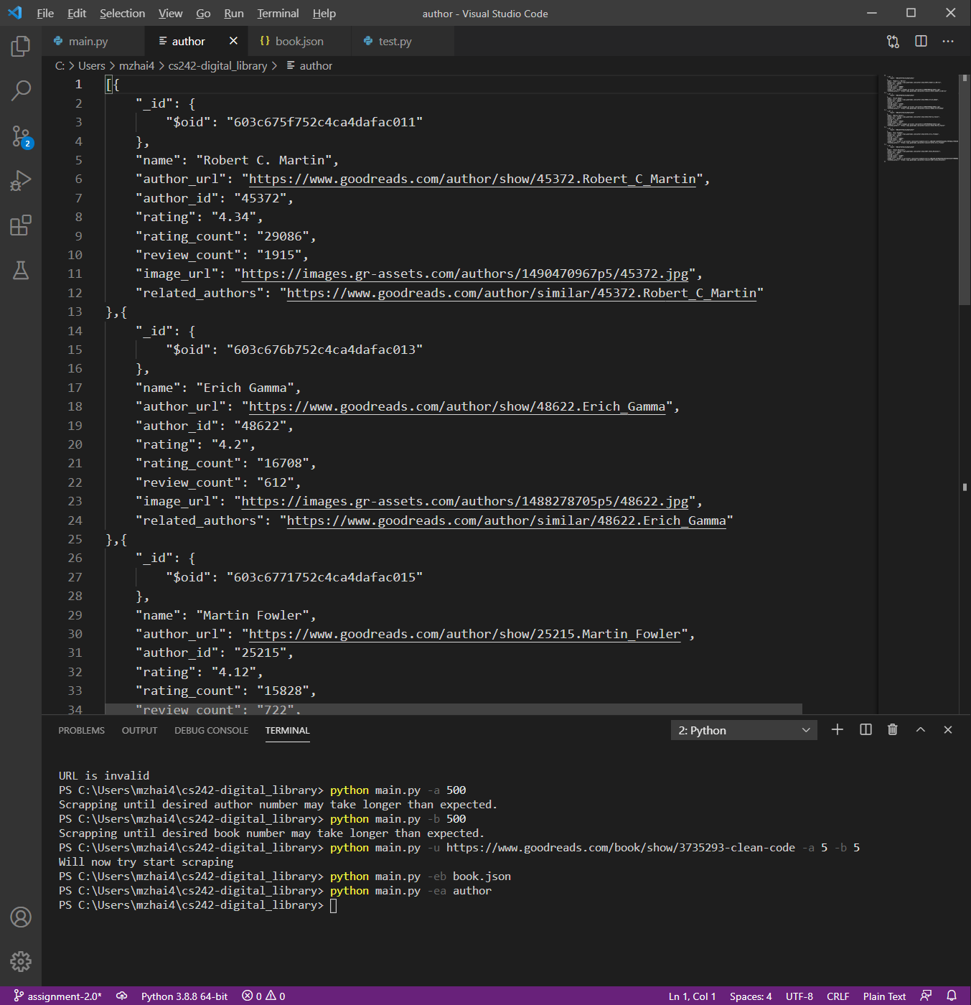

If you try to read from an invalid json file, or a malformed json file, it will tell you invalid.



If the json file is valid and the insert is successful, the program will terminate.

